Malam Jabba Hill Station with Snow City

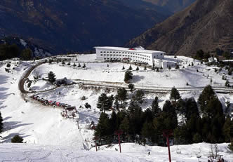
Malam Jabba is home to the only ski resort in Pakistan. The area also contains two Buddhist stupas and six monasteries that are scattered around the resort. The presence of the monuments at such a height indicates that the area has been inhabited for over 2000 years.
Gilgit has an area of 38,000 square kilometres (14,672 sq mi). The region is significantly mountainous, lying on the foothills of the Karakoram mountains, and has an average altitude of 1,500 metres (4,900 ft). It is drained by the Indus River, which rises in the neighbouring regions of Ladakh and Baltistan.

http://www.pakvisit.com/pakistan/malam_jabba.html

